|  |  |
| --- | --- |
| LIFE logo | **HOLY CROSS COLLEGE**  **SEMESTER 2, 2019**  **Question/Answer Booklet** |

Please place your student identification label in this box

12 PHYSICS

Student Name ___________________________________

Student’s Teacher __________________________________________

#### **Time allowed for this paper**

Reading time before commencing work: 10 minutes

Working time for paper: 3 hours

**Materials required/recommended for this paper**

**To be provided by the supervisor**

This Question/Answer Booklet

Multiple-choice Answer Sheet

Data Sheet

***To be provided by the candidate***

Standard items: pens, pencils, eraser, correction fluid, ruler, highlighters

Special items: non-programmable calculators satisfying the conditions set by the School Curriculum and Standards Authority for this course

**Important note to candidates**

No other items may be taken into the examination room. It is **your** responsibility to ensure that you do not have any unauthorised notes or other items of a non‑personal nature in the examination room. If you have any unauthorised material with you, hand it to the supervisor **before** reading any further.

**Structure of this paper**

|  |  |  |  |  |  |
| --- | --- | --- | --- | --- | --- |
| Section | Number of questions available | Number of questions to be answered | Suggested working time  (minutes) | Marks available | Percentage of exam |
| Section One:  Short Answers | 11 | 11 | 50 | 49 | 28 |
| Section Two:  Problem-solving | 7 | 7 | 90 | 92 | 52 |
| Section Three:  Comprehension | 2 | 2 | 40 | 36 | 20 |
|  | | | | 177 | 100 |

**Instructions to candidates**

1. The rules for the conduct of examinations at Holy Cross College are detailed in the College Examination Policy*.* Sitting this examination implies that you agree to abide by these rules.

2. Write your answers in this Question/Answer Booklet.

3. Working or reasoning should be clearly shown when calculating or estimating answers.

4. You must be careful to confine your responses to the specific questions asked and to follow any instructions that are specific to a particular question.

5. Spare pages are included at the end of this booklet. They can be used for planning your

responses and/or as additional space if required to continue an answer.

• Planning: If you use the spare pages for planning, indicate this clearly at the top of the

page.

• Continuing an answer: If you need to use the space to continue an answer, indicate in

the original answer space where the answer is continued, i.e. give the page number.

Fill in the number of the question(s) that you are continuing to answer at the top of the

page.

6. Answers to questions involving calculations should be ***evaluated and given in decimal***

***form*.** It is suggested that you quote all answers to ***three significant figures***, with the

exception of questions for which estimates are required. Despite an incorrect final result,

credit may be obtained for method and working, providing these are ***clearly and legibly set***

***out***.

7. Questions containing the instruction *"****estimate****"* may give insufficient numerical data for their

solution. Students should provide appropriate figures to enable an approximate solution to

be obtained. Give final answers to a maximum of ***two significant figures*** and include appropriate units where applicable.

8. Note that when an answer is a vector quantity, it must be given with magnitude and direction.

9. In all calculations, units must be consistent throughout your working.

**Section One: Short response 28% (49 Marks)**

This section has **11** questions. Answer **all** questions.

Suggested working time: 50 minutes.

**Question 1 (4 marks)**

Mars’ mass is 6.39 × 1023 kg and has an orbital radius around the Sun of 228 million kilometres. Calculate the ***weakest*** gravitation force that can act between Earth and Mars, assuming both Earth and Mars have circular orbits.

Answer: __________________ N

**Question 2 (4 marks)**

An electron with 2.80 eV of kinetic energy bombards an atom with a single ground state electron. The atom’s electron is excited and later transitions back to the ground state, emitting a single 518 nm photon. Calculate the kinetic energy (in eV) of the bombarding electron after it scattered off the atom.

Answer: __________________ eV

**Question 3 (4 marks)**

A 30.0 g golf ball at a mini-golf course approaches a small vertical loop obstacle at 3.45 ms-1. The ball follows the track, completing the vertical loop.

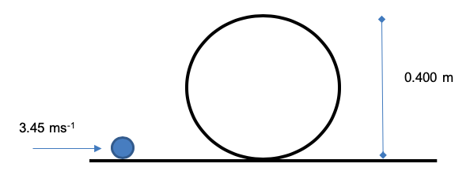

Calculate the magnitude of the reaction force applied to the ball by the track when the ball is at the top of the loop.

Answer: __________________ N

**Question 4 (4 marks)**

The diagram below shows an electron entering a uniform 2.00 NC-1 electric field. There is also a magnetic field in this region (not shown on the diagram).

Electron Velocity

Electric Field

The electron has a constant velocity of 8540 ms-1 while in the presence of the two fields. State the direction of the magnetic field and calculate its strength.

Direction: __________________ Strength: __________________ T

**Question 5 (4 marks)**

The following particle reaction is proposed by a PhD student while studying new, exotic particles of the standard model.

$$udb→c\overline{c}+s\overline{u}+uud$$

Justify whether this reaction is possible based on baryon number, lepton number and electric charge.

**Question 6 (4 marks)**

A square coil moves into a uniform 0.260 T magnetic field that is aligned perpendicular to the area of the coil. The coil is induced with a 0.650 V EMF as it enters the field at 4.75 ms-1. Considering the movement of the ***coil as it moves into the field only***, for what amount of time does the coil have an induced EMF?

X X X

X X X

X X X

X X X

Answer: __________________ s

**Question 7 (4 marks)**

The red-shift of light from galaxies not our own is supporting evidence of the Big Bang Theory. Describe what causes the increasing amount of red-shift of light from galaxies further away and why *only* nearby galaxies may have blue-shifted light.

|  |
| --- |
|  |
|  |
|  |
|  |
|  |
|  |
|  |
|  |
|  |
|  |

**Question 8 (5 marks)**

Laptop chargers are traditional transformers that create an alternating current in the secondary coil.

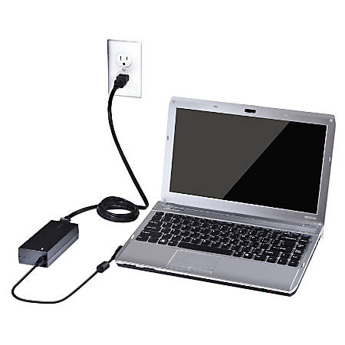

240 V mains supply

3.75 A supplied to laptop

Charger

the above situation is shown below.

(a) Explain briefly how the transformer creates an alternating current in the secondary coil.  
 (3 marks)

|  |
| --- |
|  |
|  |
|  |
|  |
|  |
|  |
|  |

(b) Using information from the diagram, calculate the potential difference that the charger provides to the laptop. (2 marks)

Answer ____________V

**Question 9 (5 marks)**

The photoelectric effect can be demonstrated by illuminating a negatively-charged electroscope, with ultraviolet (UV) light. In an electroscope, the vein rises when the vein and post have like charges. A particular electroscope has a zinc metal plate. Once the electroscope was charged, a student switched on an ultraviolet light. After a few seconds, the electroscope was discharged as electrons were emitted from the surface of the zinc.

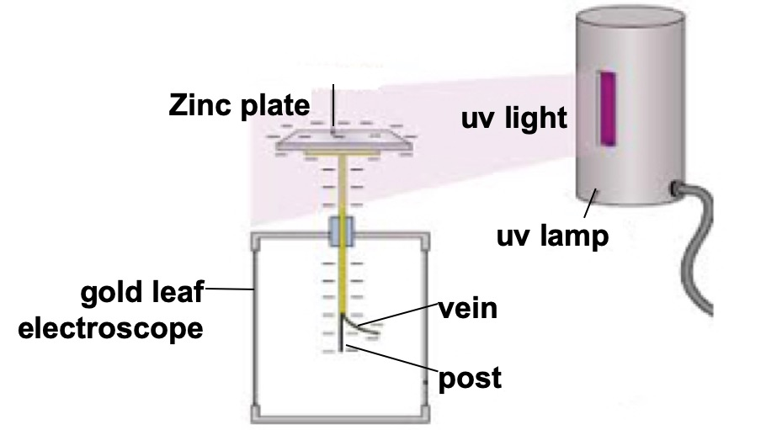

(a) Would a positively charged electroscope have been discharged in the same way? Explain. (2 marks)

|  |
| --- |
|  |
|  |
|  |
|  |
|  |
|  |

(b) Calculate the velocity of the emitted electrons, if the UV light has a frequency of

1.20 x 1015 Hz. The work function of zinc is 4.30 eV. (3 marks)

Answer ______________ms-1

**Question 10 (6 marks)**

The figure on the left below shows the side view of an electron diffraction tube used to demonstrate the wave properties of an electron. An electron beam is incident on a thin graphite target that behaves like the slits in a diffraction grating experiment. After passing through the graphite target the electrons strike a fluorescent screen. The figure on the right below shows the appearance of the fluorescent screen when the electrons are incident on it.

(a) Explain how the pattern produced on the screen supports the idea that the electron beam is behaving as a wave rather than as a stream of particles. (2 marks)

|  |
| --- |
|  |
|  |
|  |
|  |
|  |

(b) When the electrons strike the graphite target, they have a speed of 2.20 x 107 ms-1.

(i) Calculate the potential difference required to accelerate the electrons to this speed.

(2 marks)

Answer ____________ V

(ii) Calculate the de Broglie wavelength of the electrons as they strike the graphite. (2 marks)

Answer ____________ m

**Question 11 (5 marks)**

During a lightning strike, there is a ***negative*** discharge from a cloud to the ground. This discharge produces a 325 kA current that falls to 0.00 A in 50.0 μs. There is a 55-turn coil of radius 0.800 m placed 225 m from the strike as shown below.



225 m

0.800 m

55 turn coil

* diagram not to scale

(a) On the diagram indicate the direction of the induced EMF in the coil. (1 mark)

(b) Calculate the average EMF induced in the coil during this strike. (4 marks)

Answer ___________ V

**End of Section One**

**Additional working space**

**Section Two: Problem-solving 50% (92 Marks)**

This section has **seven (7)** questions. Answer **all** questions. Write your answers in the spaces provided.

Suggested working time: 90 minutes.

**Question 12 (12 marks)**

Claire is standing on Earth. She observes Jim passing by in a spaceship at 0.600 c. Jim observes the spaceship to be 18.0 m long. Jim is playing hyperspace pong where he hits a ball towards the front of the spaceship from the back at 0.400 c (according to Jim). The ball has a rest mass of 0.500 kg.

1. What time does Jim observe the ball take to reach the front of the spaceship? (2 marks)

Answer: __________________ s

1. As the ball completes the journey towards the front of the spaceship, does Jim observe the proper length of the ball’s journey or the proper time for the ball’s journey or both? Justify your choice. (2 marks)

|  |
| --- |
|  |
|  |
|  |
|  |
|  |

1. How long is the spaceship as measured by Claire? (2 marks)

Answer: __________________ m

1. What is the velocity of the ball as measured by Claire? Give your answer in terms of the speed of light *c*. (2 marks)

Answer: __________________ c

1. Calculate the total energy of the ball as measured by Jim. (2 marks)

Answer: __________________ J

1. Calculate the momentum of the ball as measured by Claire. (2 marks)

Answer: __________________ kgms-1

**Question 13 (12 marks)**

A trebuchet is a siege weapon that flings boulders from a great distance. Consider the arrangement of a trebuchet and a castle shown below.

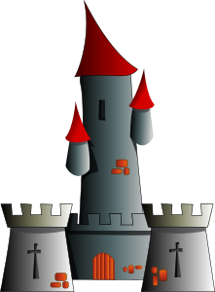

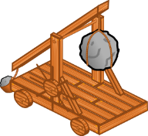

$$s_{h}=326 m$$

1. The boulder lands at the same height from which it was launched, was fired at 45.00 above the horizontal and was airborne for 8.16 s. Complete the following questions.
   * 1. Calculate the launch velocity of the boulder. (3 marks)

Answer: __________________ ms-1

* + 1. Calculate the maximum height the boulder achieved above its launch point. (3 marks)

Answer: __________________ m

Medieval castles were often built at higher elevations to give an advantage to those under siege.

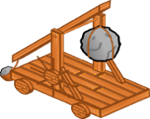

1. A launched boulder is in the air for 4.80 s. The distances $s_{h}$ and $s_{v}$ above indicate how far the boulder travelled to hit the castle. Determine both the speed and angle above the horizon that the boulder was launched. Air resistance can be ignored. (6 marks)

Speed: __________________ ms-1 Angle: ___________ 0

**Question 14 (13 marks)**

A small rectangular coil ABCD contains 140 turns of wire. The sides AB and BC of the coil

are of lengths 4.50 cm and 2.80 cm respectively, as shown in the figure below.

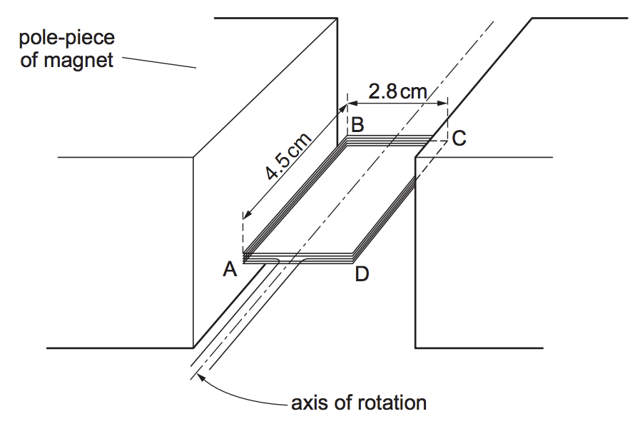

N

S

The coil is held between the poles of a large magnet so that the coil can rotate about an axis through its centre. When the current in the coil is 170 mA and the coil is stationary, the maximum torque produced in the coil is 2.10 × 10–3 Nm.

(a) For the coil in the position shown calculate the magnitude of the force on:

(i) side AB of the coil (3 marks)

Answer __________ N

(ii) side BC of the coil (1 mark)

Answer __________ N

(b) Calculate the strength of the magnetic field experienced by the sides of the coil. (2 marks)

Answer: ___________ T

(c) The above diagram does not show how the coil is connected to a potential difference. Of the two mechanisms shown below, which mechanism should be used for the coil to rotate as a DC motor. Name the mechanism and explain your choice. (3 marks)

|  |
| --- |
|  |
|  |
|  |
|  |
|  |
|  |
|  |
|  |

(d) Once the coil has started rotating as a DC motor, does the maximum torque ***increase***, ***decrease*** or ***remain*** ***the*** ***same***. Explain your answer. (4 marks)

|  |
| --- |
|  |
|  |
|  |
|  |
|  |
|  |
|  |
|  |
|  |

**Question 15 (15 marks)**

During an experiment, a pendulum is set up, as shown in the diagram. The length of the cord attached to the bob is 1.55 m. The bob has a mass of 1.80 kg and is released from rest from the position shown. At the lowest point of its path, the bob is 7.80 cm beneath its starting point.

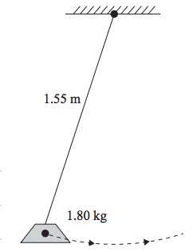

7.80 cm

(a) By considering conservation of energy, calculate the velocity of the bob at its lowest point**.** (3 marks)

Answer = ______________ms-1

(b) Calculate the tension in the cord at the lowest point of its path. (3 marks)

Answer = _________________N

Later, the experimental setup is modified so that the bob swings in a horizontal circular path, with radius 0.290 m, as a conical pendulum.

(c) On the above diagram, indicate all forces acting on the bob. Clearly label the forces using arrows. (3 marks)

(d) Show that the tension in the cord is now about 18.0 N. (3 marks)

(e) Calculate the magnitude of the velocity of the bob at the position shown. (3 marks)

Answer ________________ms1

**Question 16 (13 marks)**

Digital television in Australia can be accessed by using a satellite dish pointed at a satellite in space. The satellite used to transmit the signals appears to stay still relative to the Earth.

The satellite, with a mass of 300 kg, is actually travelling around the Earth in a geostationary orbit.

The picture below shows the three main types of satellite orbits. Low Earth Orbits (LEO), Medium Earth Orbits (MEO) and Geostationary Earth Orbits (GEO).

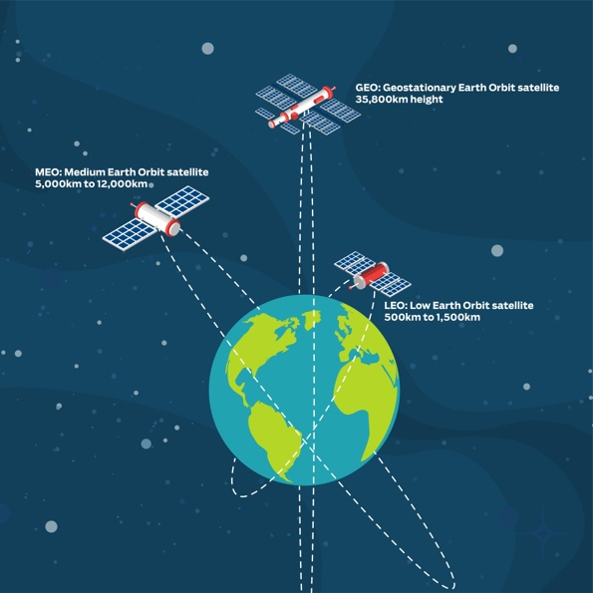

GEO: Geostationary Earth Orbit satellite 35,800 km height.

LEO: Low Earth Orbit satellite 500 km to 1,500 km height.

MEO: Medium Earth Orbit satellite 5,000 km to 12,000 km height.

(a) In the picture, there is an error with the indicated orbit of a GEO satellite. Indicate this error and explain why the orbit shown must be an error. (2 marks)

|  |
| --- |
|  |
|  |
|  |
|  |

(b) Which of these satellites experiences the greatest gravitational force from the Earth? Circle the correct answer from the choices below. Explain your answer in the space provided.

(2 marks)

LEO MEO GEO All satellites experience the same force

Explanation

|  |
| --- |
|  |
|  |
|  |
|  |

(c) Which of these satellites is travelling at the greatest speed relative to the Earth? Circle the correct answer from the choices below. Explain your answer in the space provided.

(3 marks)

LEO MEO GEO All satellites have the same speed

Explanation

|  |
| --- |
|  |
|  |
|  |
|  |

(d) Kepler’s Third Law is given on your data sheet. By using relevant equations, in the space below, derive Kepler’s Third Law. (3 marks)

(e) Using the information in the picture, calculate the minimum period of a LEO satellite.

(3 marks)

Answer: ______________ s

**Question 17 (13 marks)**

The diagram below shows an AC generator consisting of a rectangular coil with dimensions of

14.0 cm × 21.0 cm and 800 turns of copper wire. The magnetic flux density between the poles is 9.40 mT. The coil is turned at a uniform rate.

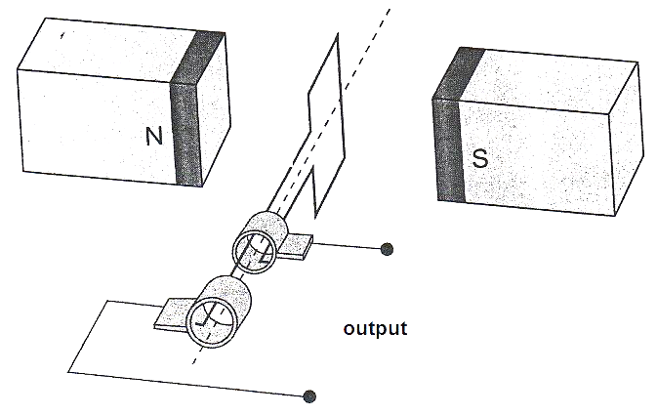

**SR**

**B**

**B**

1. Explain the function of the components labelled SR and B. (2 marks)

|  |
| --- |
|  |
|  |
|  |
|  |
|  |
|  |

1. Referring to Lenz’s law, explain how induced EMF is achieved from such a generator and why the output is a sine or cosine shape rather than being constant. (3 marks)

|  |
| --- |
|  |
|  |
|  |
|  |
|  |
|  |
|  |
|  |

1. The coil is rotated at 1500 rpm. Calculate the magnitude of the average induced EMF in the coil as it rotates through 90º from the position shown. (3 marks)
2. Sketch the EMF output curve for this AC generator on the graph below. You must start from the position shown on the diagram and continue up to 80 ms. Make estimates for values that you cannot calculate. (3 marks)



1. Identify three times on the graph when the flux enclosed by the coil is a maximum value at 1500 rpm. Circle these times. (1 mark)
2. When the coil is rotated at 750 rpm, the EMF output changes. Sketch the voltage curve for 750 rpm onto the graph and clearly label it ‘750 rpm’. (1 mark)

**Question 18 (14 marks)**

A gantry crane is being used to lift a 2.50 tonne crate as shown in the diagram below. The gantry consists of a 4.32 tonne, 21.0 m uniform beam that is supported by two 10.0 m support columns A and B. The 2.50 tonne crate is 4.50 m from the centre of column A and 16.50 m from column B. There is a 750 kg winch whose centre of mass is directly above the centre of mass the crate.

(a) On the diagram above, labelling all forces acting on the beam. Include the magnitude of the downward forces in the diagram. (4 marks)

(b) Calculate the reaction force provided by each column on the beam. (4 marks)

Reaction force Column A: ___________ N Reaction force Column B: ___________ N

In a variation of the gantry crane, the beam is supported by one column, pivoted at its base and at its point of attachment with the beam, which is held in place by a steel cable attached to a large concrete block. The beam is supported by a 250 kg strut CD, which is pivoted at both ends. CD makes an angle of 60.0o with the beam and is attached 11.0 m from the right-hand end of the beam. The cable makes an angle of 40.0o with the support column.

(c) Calculate the tension in the steel cable. (3 marks)

Answer: _________________ N

(d) Calculate the force of compression in strut CD. (3 marks)

Answer: _______________________ N

**End of Section Two**

**Section Three: Comprehension 20% (36 Marks)**

This section has two (2) questions. Write your answers in the spaces provided.

Spare pages are included at the end of this booklet. They can be used for planning your responses and/or as additional space if required to continue an answer.

Suggested working time: 40 minutes.

**Question 19 (18 marks)**

***The Universe Has A Speed Limit, And It Isn’t The Speed Of Light***

When it comes to speed limits, the ultimate one set by the laws of Physics themselves is the speed of light. Moreover, anything that’s made of matter can only approach, but never reach, the speed of light. If you don’t have mass, you must move at the speed of light; if you do have mass, you can never reach it. But practically, in our universe, there’s an even more restrictive speed limit for matter, and it’s lower than the speed of light. Here’s the scientific story of the real cosmic speed limit.

When scientists talk about the speed of light  - 299,792,458 ms-1  - we implicitly mean 'the speed of light in a vacuum'. Only in the absence of particles, fields or a medium to travel through can we achieve this ultimate cosmic speed. Even at that, it’s only the truly massless particles and waves that can achieve this speed. This includes photons, gluons and gravitational waves, but not anything else we know of. But there’s no such thing, practically, as a perfect vacuum. Even in the deepest abyss of intergalactic space, there are three things you absolutely cannot get rid of.

1. The WHIM: the warm-hot intergalactic medium. This tenuous, sparse plasma is the leftovers from the cosmic web. While some matter clumps into stars and galaxies, other matter remains in the great voids of the universe. Starlight ionises these atoms, creating a plasma that may make up about 50% of the total normal matter in the universe.
2. The CMB: the cosmic microwave background. This leftover bath of photons originates from the Big Bang, where it was at extremely high energies. Even today, at temperatures just 2.7 degrees above absolute zero, there are over 400 CMB photons per cubic centimetre of space at an average energy of 0.00023 eV per photon.
3. The CNB: the cosmic neutrino background. The Big Bang, in addition to photons, creates a bath of neutrinos. Outnumbering protons by perhaps a billion to one, many of these now slow-moving particles fall into galaxies and clusters, but many remain in intergalactic space as well.

Any particle travelling through the universe will pass through particles from the WHIM, neutrinos from the CNB and photons from the CMB.

The Large Hadron Collider accelerates particles here on Earth up to a maximum velocity of 299,792,455 ms-1, or 99.999999% the speed of light. The highest-energy cosmic rays have approximately 36 million times the energy of the fastest protons ever created at the Large Hadron Collider. Assuming that these cosmic rays are also made of protons gives a speed of 299,792,457.99999999999992 ms-1, which is extremely close to, but still below, the speed of light in a vacuum. There’s a very good reason that, by the time we receive them, these cosmic rays aren’t more energetic than this.

If there is a particle with energies in excess of 5.00 × 10¹⁹ eV, they can only travel a few million light years  - max - before a photon from the CMB, interacts with it. When that interaction occurs, there will be enough energy to produce a neutral pion, which steals energy away from the original particle, following from $E=mc^{2}$.

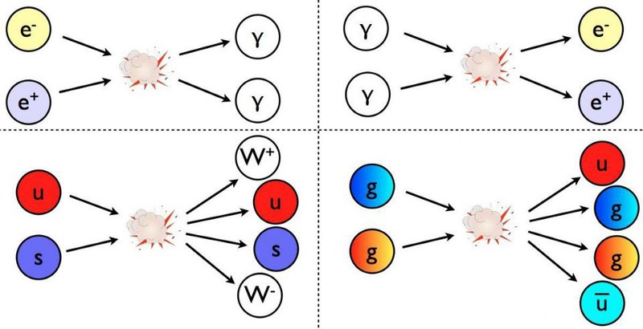

The more energetic your particle is, the more likely you are to produce pions, which you’ll continue to do until you fall below this theoretical cosmic energy limit of 5.00 × 10¹⁹ eV, known as the GZK cut-off.

We believe that every charged particle in the cosmos - every cosmic ray, every proton, every atomic nucleus - should be limited by this speed. Not just the speed of light, but a little bit lower, thanks to the leftover glow from the Big Bang and the particles in the intergalactic medium. If we see anything that’s at a higher energy, then it means:

1. either particles at high energies might be playing by different rules than the ones we presently think they do,
2. or they are being produced much closer than we think they are: within our own Local Group or Milky Way, rather than these distant, extragalactic black holes,
3. or they’re not protons at all, but composite nuclei.

The few particles we’ve seen that break the GZK barrier are indeed in excess of 5 × 10¹⁹ eV, in terms of energy, but do not exceed 3 × 10²¹ eV, which would be the corresponding energy value for an iron nucleus. Since many of the highest-energy cosmic rays have been confirmed to be heavy nuclei, rather than individual protons, this reigns as the most likely explanation for the extreme ultra-high-energy cosmic rays.

There is a speed limit to the particles that travel through the universe, and it isn’t the speed of light. Instead, it’s a value that’s very slightly lower, dictated by the amount of energy in the leftover glow from the Big Bang. As the universe continues to expand and cool, that speed limit will slowly rise over cosmic timescales, getting ever-closer to the speed of light. But remember, as you travel through the universe, if you go too fast, even the radiation left over from the Big Bang can fry you. So long as you’re made of matter, there’s a cosmic speed limit that you simply cannot overcome.

(a) Name three things in the universe that can move at the cosmic speed limit and describe the requirements to reach the cosmic speed limit. (3 marks)

|  |
| --- |
|  |
|  |
|  |
|  |
|  |
|  |
|  |

(b) A neutral pion has a rest mass of 135 MeV/c2. Calculate the minimum number of neutral pions that need to be produced by a 5.03 × 1019 eV particle to reduce to the cosmic energy limit. (3 marks)

(c) The article compares the Large Hadron Collider and cosmic rays. Protons in the Large Hadron Collider are accelerated up to 6.50 TeV. What is the energy of the most energetic cosmic rays in eV? (3 marks)

Answer: __________________ eV

(d) Calculate the average frequency of a photon from the CMB. (3 marks)

Answer: __________________ Hz

(e) Explain why the interaction of a very energetic particle with a photon can cause the particle to slow down. (3 marks)

|  |
| --- |
|  |
|  |
|  |
|  |
|  |
|  |
|  |

(f) Describe which of the three reasons given in the article is the most likely cause when we have detected particles more energetic than the GZK barrier. (3 marks)

|  |
| --- |
|  |
|  |
|  |
|  |
|  |
|  |
|  |

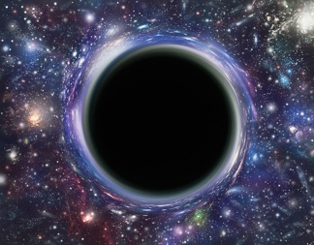**Question 20 (18 marks)**

***Escape velocity and The Black Hole***

Article adapted from Fundamentals of Modern Physics by Peter J Nolan. 2014

The simplest way to describe the black hole is to start with a classical analogue. Suppose we wished to launch a rocket from the Earth to a far distant place in outer space. How fast must the rocket travel to escape the gravitational pull of the Earth? This value is known as the ***escape velocity***.

When we launch the rocket, it has a velocity ***v***, and hence, a kinetic energy. As the rocket proceeds into space, its velocity decreases but its potential energy increases. The absolute potential energy of an object when it is a distance ***r*** away from the centre of the Earth is found from:

where ***G*** is the universal gravitational constant, ***Me*** is the mass of the Earth, and ***m*** is the mass of the object.

Let us now apply this potential energy term to a rocket that is trying to escape from the gravitational pull of the Earth. The total energy of the rocket at any time is equal to the sum of its potential energy and its kinetic energy, that is:

When the rocket is fired from the surface of the Earth, ***r*** = ***R***, at an escape velocity ***v­e***, its total energy will be:

By the law of conservation of energy, the total energy of the rocket remains a constant. Hence, we can equate the total energy at the surface of the Earth to the total energy when the rocket is far removed from the Earth. That is:

When the rocket escapes the pull of the Earth, it has effectively travelled to infinity, that is, ***r*** = ∞, and its velocity at that time is reduced to zero, that is, ***v*** = 0. Hence, the equation reduces to:

If we substitute ***ve*** for the ***c*** (the speed of light) and rearrange, we get a formula that tells us the maximum radius of any object with mass, for light to be able to escape from it.

$$R_{S}= \frac{2GM_{e}}{c^{2}}$$

This value is called the ***Schwarzchild radius***and any distance to an object closer than this value is said the be within the ***event horizon***, a region from which nothing, not even light, can escape!

The reason for the name, black hole, comes from the idea that if we look at an object in space, such as a star, we see light coming from that star. If the star became a black hole, no light could come from that star. Hence, when we look into space, we would no longer see a bright star at that location, but rather nothing but the blackness of space. There seems to be a hole in space where the star used to be and therefore, we say that there is a black hole there.

Solving the Schwarzschild radius of the Sun, by replacing the mass of the Earth by the mass of the Sun, we get 2.95 x 103 m. Thus, if the Sun were to contract to a radius below 2.95 x 103 m, the gravitational force would become so great that no light could escape from the Sun, and the Sun would become a black hole.

(a) Explain the relationship between the concept of ***escape velocity*** and the concept of a ***black hole***. (2 marks)

|  |
| --- |
|  |
|  |
|  |
|  |
|  |
|  |

(b) The article states that:

*'When the rocket escapes the pull of the earth it has effectively travelled to infinity, that is,*

*r = ∞, and its velocity at that time is reduced to zero, that is, v = 0.'*  
  
 (i) Use Newton’s Law of Universal Gravitation to support the argument that at r = ∞, the rocket has escaped the pull of the Earth. (2 marks)

(ii) If an object left the Earth with the minimum escape velocity, why would this value be zero, when ***r*** is equal to infinity? (2 marks)

|  |
| --- |
|  |
|  |
|  |
|  |
|  |

(c) (i) Show that the escape velocity for an object to leave the Earth’s gravitational pull is equal to 1.12 x 104 ms-1. (2 marks)

(ii) Show that the total energy of 12.0 tonne space craft launched at its escape velocity from the surface of the Earth is zero. (3 marks)

(iii) At what speed would this space craft be travelling in deep space at a distance of 325 million kilometres from the Earth? (4 marks)

Speed = ________ ms-1

(d) One of the largest stars in our galaxy is Betelgeuse. This star has a radius 887 times that of our Sun and a mass 11.6 times that of our Sun. Explain what is meant by the ***Schwarzschild radius***for this starand calculate is value. (3 marks)

Schwarzschild radius: _________________ m

**End of Examination**

**Additional working space**

**Additional working space**